AI Job Market Analysis 2025–2026

IBM Data Analytics and AI Internship — Final Project Report

Dataset: AI Job Market Dataset 2025–2026 (Kaggle)
Tool: Python (pandas, matplotlib, seaborn, plotly, streamlit)
Total Records: 1,500 | Job Roles: 25 | Countries: 14 | Industries: 12
Year: 2025–2026

Table of Contents
- 1. Introduction
- 2. Problem Statement
- 3. Objectives
- 4. Dataset Description
- 5. Dataset Source
- 6. Technologies Used
- 7. Data Cleaning & Quality
- 8. Exploratory Data Analysis
- 9. KPI Analysis
- 10. Visualizations
- 11. Key Findings
- 12. Risks
- 13. Opportunities
- 14. Recommended Actions
- 15. Results & Dashboard
- 16. Conclusion
- 17. Limitations

1. Introduction
Artificial Intelligence (AI) is transforming the global workforce at an unprecedented pace. Understanding the dynamics of the AI job market — including salary trends, skill demand, geographic distribution, and emerging roles — is critical for job seekers, employers, policymakers, and educators alike.
This project presents a complete data analytics study of the AI job market for 2025–2026 using a curated dataset of 1,500 AI job postings. The analysis covers 25 distinct job roles across 14 countries and 12 industries, providing actionable insights into compensation, demand, skills, and work models.

2. Problem Statement
As AI adoption accelerates across industries, questions arise: Which AI roles command the highest salaries? What skills are most in demand? How is remote work distributed across roles and countries? Which roles are growing fastest? This project addresses these questions by performing a rigorous, data-driven analysis of the 2025–2026 AI job market dataset.

3. Objectives
- Load, inspect, and clean the AI jobs dataset for analysis.
- Perform exploratory data analysis (EDA) on salary, demand, skills, and work models.
- Calculate key performance indicators (KPIs) such as average salary, median salary, demand score, and YoY growth.
- Identify the highest-paying roles, fastest-growing roles, and most in-demand skills.
- Analyse the impact of experience level, education, company size, and geography on salary.
- Build an interactive Streamlit dashboard for visual exploration.
- Document findings, risks, opportunities, and recommended actions.

4. Dataset Description
The dataset contains 1,500 AI job postings with 25 columns covering the following dimensions:
- Job identification: job_id, job_title, job_category
- Experience: experience_level (Entry/Mid/Senior/Lead), years_of_experience
- Education: education_required (Bachelor's, Master's, PhD, Associate's, Bootcamp)
- Compensation: annual_salary_usd, salary_min_usd, salary_max_usd, salary_tier, ai_salary_premium_pct
- Location: city, country (14 countries including USA, UK, Germany, India, Japan, etc.)
- Work model: remote_work (On-site, Hybrid, Fully Remote), is_remote_friendly
- Company: company_size (Startup, SME, Mid-size, Enterprise, Big Tech)
- Industry: industry (12 sectors: Finance, Healthcare, Technology, Automotive, etc.)
- Skills: required_skills (pipe-separated skill tags)
- Metrics: demand_score, demand_growth_yoy_pct, benefits_score_10
- Flags: is_senior, is_remote_friendly, is_llm_role, posting_year, posting_month

Key Dataset Statistics:
Metric | Value
Total Records | 1,500
Unique Job Roles | 25
Countries | 14
Industries | 12
Posting Years | 2025, 2026
Missing Values | None (0)
Duplicate Rows | 0
Salary Range | $90,000 – $384,000

5. Dataset Source
The dataset "AI Job Market Dataset 2025-2026" is sourced from Kaggle, a public data science and machine learning community platform.
Kaggle Dataset URL: https://www.kaggle.com/datasets/ai-job-market-2025-2026
Note: This is a curated/synthetic dataset designed to represent AI job market trends. It does not represent the complete global AI job market and should be treated as indicative data for educational and analytical purposes.

6. Technologies Used
Technology | Purpose
Python 3.x | Core programming language
pandas | Data loading, manipulation, and analysis
numpy | Numerical computations
matplotlib | Static data visualizations
seaborn | Statistical data visualization
plotly | Interactive charts for Streamlit dashboard
streamlit | Interactive web dashboard
python-docx | Word report generation
Jupyter Notebook | Interactive analysis and documentation
VS Code / PyCharm | Development environment

7. Data Cleaning & Quality Assessment

7.1 Missing Values
A thorough check revealed zero missing values across all 25 columns and 1,500 rows. The dataset is complete with no imputation required.

7.2 Duplicate Records
No duplicate rows were found (0 full duplicates). All 1,500 job_id values are unique, confirming each record represents a distinct job posting.

7.3 Data Type Validation
All columns have appropriate data types: numerical salary and score columns are float64/int64, categorical columns are stored as strings, and boolean flags (is_senior, is_remote_friendly, is_llm_role) are stored as integers (0/1).

7.4 Value Consistency Checks
- Salary range: $90,000 – $384,000 — all values positive and within expected range.
- Demand score: 68–98 (out of 100) — within valid bounds.
- Benefits score: all values between 0 and 10 — valid.
- Experience level: 4 distinct ordered categories — consistent labelling.
- Remote work: 3 distinct values (On-site, Hybrid, Fully Remote) — no inconsistencies.
- Categorical columns stripped of leading/trailing whitespace during cleaning.

7.5 Feature Engineering
Two derived features were created for enhanced analysis:
- is_remote: Binary flag (1 = Hybrid or Fully Remote, 0 = On-site)
- Role Type: String label ("LLM Role" / "Non-LLM Role") derived from is_llm_role
- Ordered Categoricals: salary_tier and experience_level made ordered for correct chart sorting

8. Exploratory Data Analysis (EDA)

8.1 Salary Distribution
The annual salary distribution spans $90,000 to $384,000, with a mean of $194,892 and median of $180,000. The right skew (mean > median) indicates that a subset of elite roles pull the average upward. The majority of postings (about 60%) fall in the $150K–$300K range.
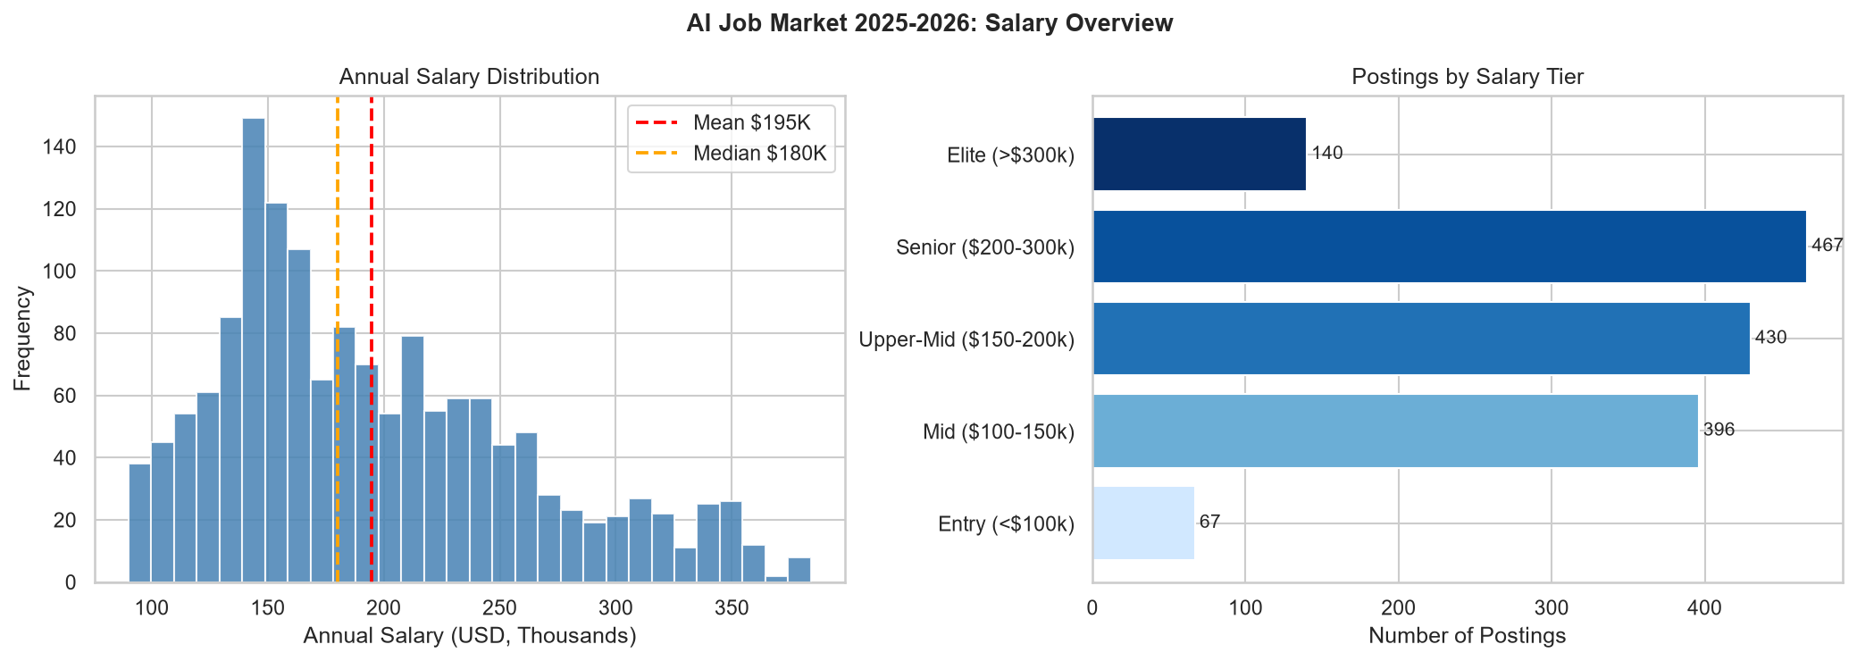
Figure 1: Annual Salary Distribution and Salary Tier Breakdown

8.2 Job Role Analysis
The dataset covers 25 distinct AI job roles. LLM Engineer leads in posting volume (75 postings), while AI Solutions Architect commands the highest average salary ($251,577). AI Engineering is the dominant category with the most roles and highest demand scores.
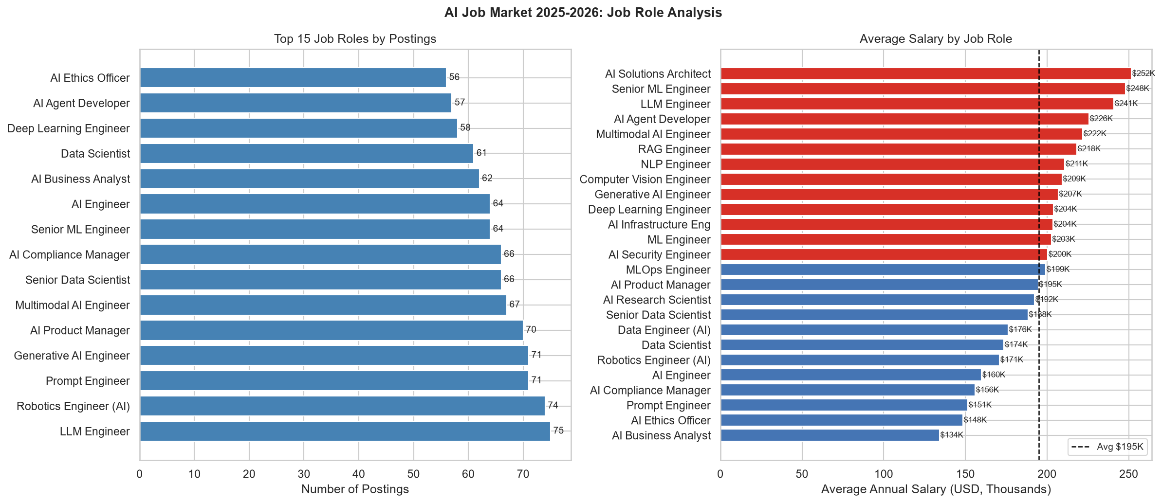
Figure 2: Top Job Roles by Postings and Average Salary

8.3 Experience Level Analysis
Salary increases substantially with experience: Entry level averages $150,039, while Lead (10+ years) averages $240,055 — a difference of $90,016. The distribution is relatively even across experience levels (approximately 25% each), suggesting diverse hiring needs.
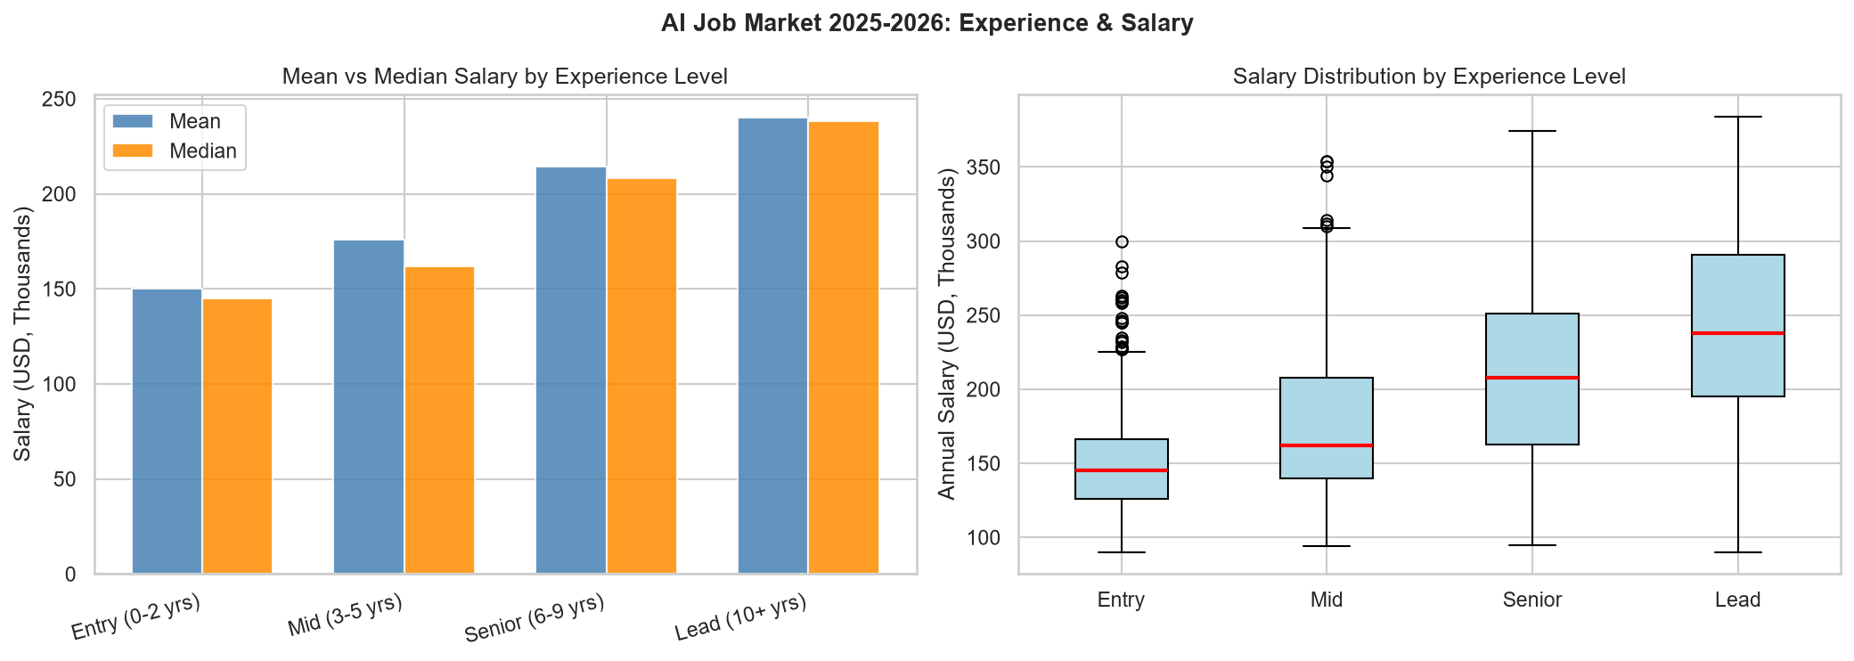
Figure 3: Salary by Experience Level — Mean, Median and Box Plot

8.4 Remote Work Analysis
Work model distribution: Hybrid (45.7%), Fully Remote (29.7%), On-site (24.6%). A total of 75.4% of postings offer flexible work arrangements, reflecting the global shift toward remote and hybrid AI work.
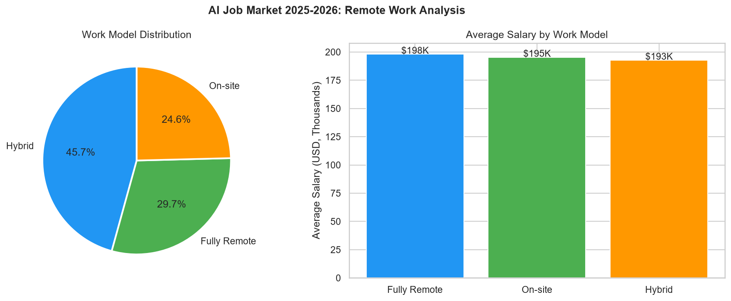
Figure 4: Work Model Distribution and Average Salary by Work Model

8.5 Country Analysis
The USA dominates with 515 postings (34.3% of total), followed by UK (90), China (87), Canada (85), and Global remote (82). For average salary, USA leads at $226,190, followed by Global remote roles at $222,044.
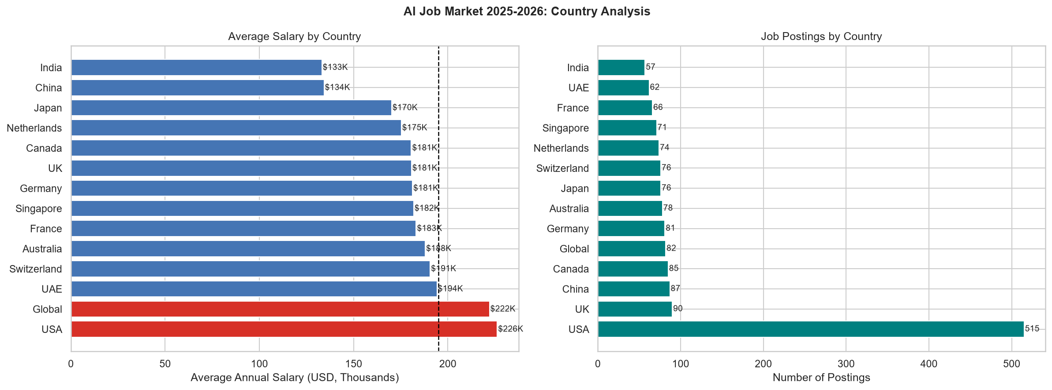
Figure 5: Average Salary and Postings by Country

8.6 Industry Analysis
Automotive leads in both postings (138) and average salary ($212,306), followed by Healthcare (138 postings, $196,188 avg). Energy has the lowest average salary ($182,857) among the 12 industries.
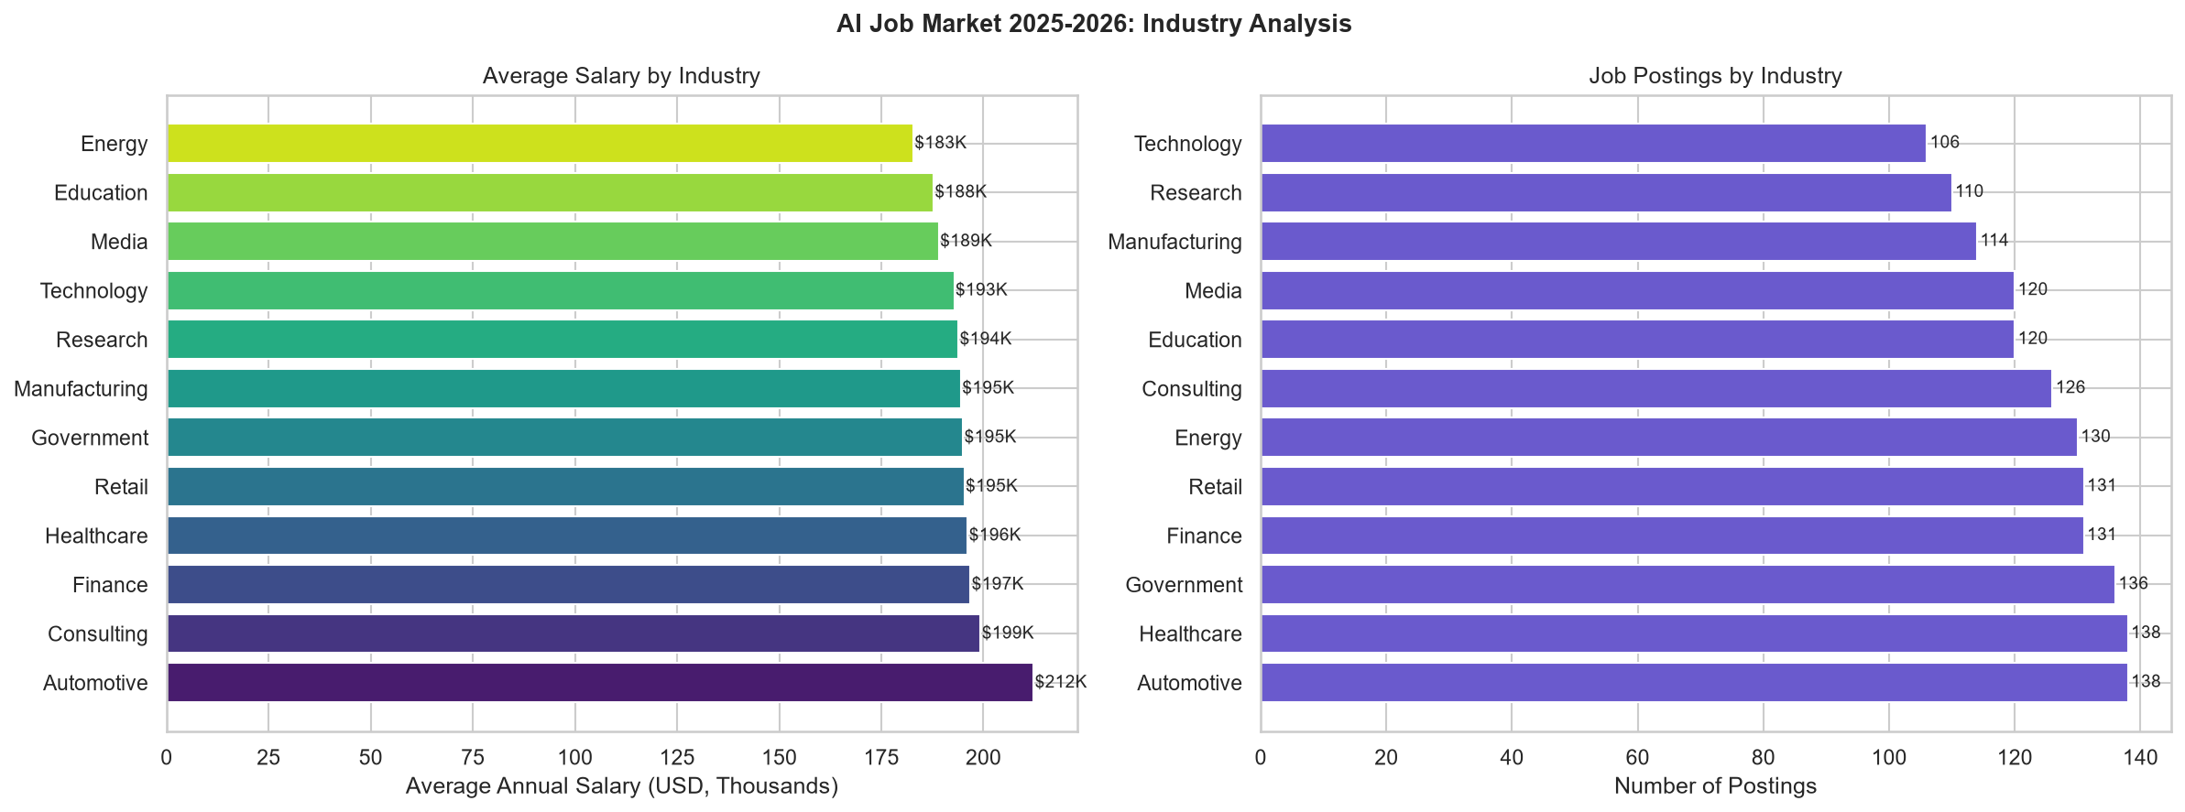
Figure 6: Average Salary and Postings by Industry

8.7 Skills Analysis
Skills were extracted from the pipe-delimited required_skills field. Python is the dominant skill, appearing in 942 postings (62.8%). SQL (452), Cloud (429), Leadership (380), and Communication (378) round out the top five. Technical LLM skills (PyTorch, Fine-tuning, LLMs) are increasingly prominent.
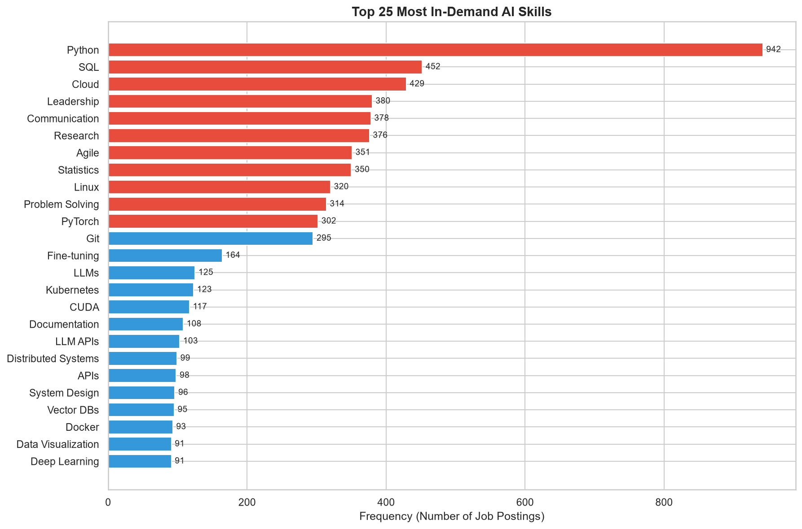
Figure 7: Top 25 Most In-Demand AI Skills

8.8 Company Size Analysis
The dataset has near-equal distribution across all five company size categories (290–312 postings each). Big Tech (FAANG+) commands the highest average salaries, while Startups tend to offer competitive salaries to attract scarce AI talent.
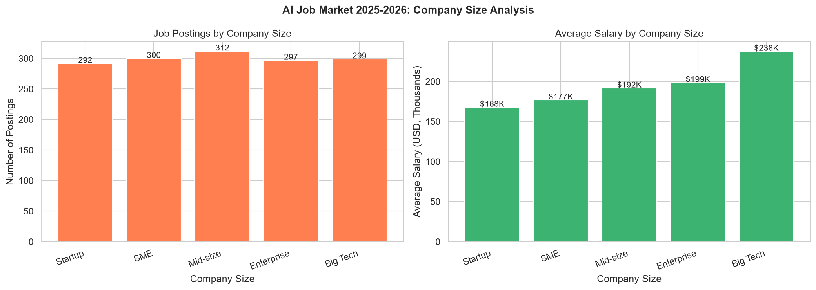
Figure 8: Postings and Salary by Company Size

8.9 Demand & Growth Trends
YoY demand growth ranges widely: RAG Engineer and NLP Engineer show the strongest growth (avg ~55% and ~55% respectively). The overall average YoY growth is 31.1%. Monthly posting trends show relatively steady volumes across 2025–2026, with slight peaks in Q1 of both years.
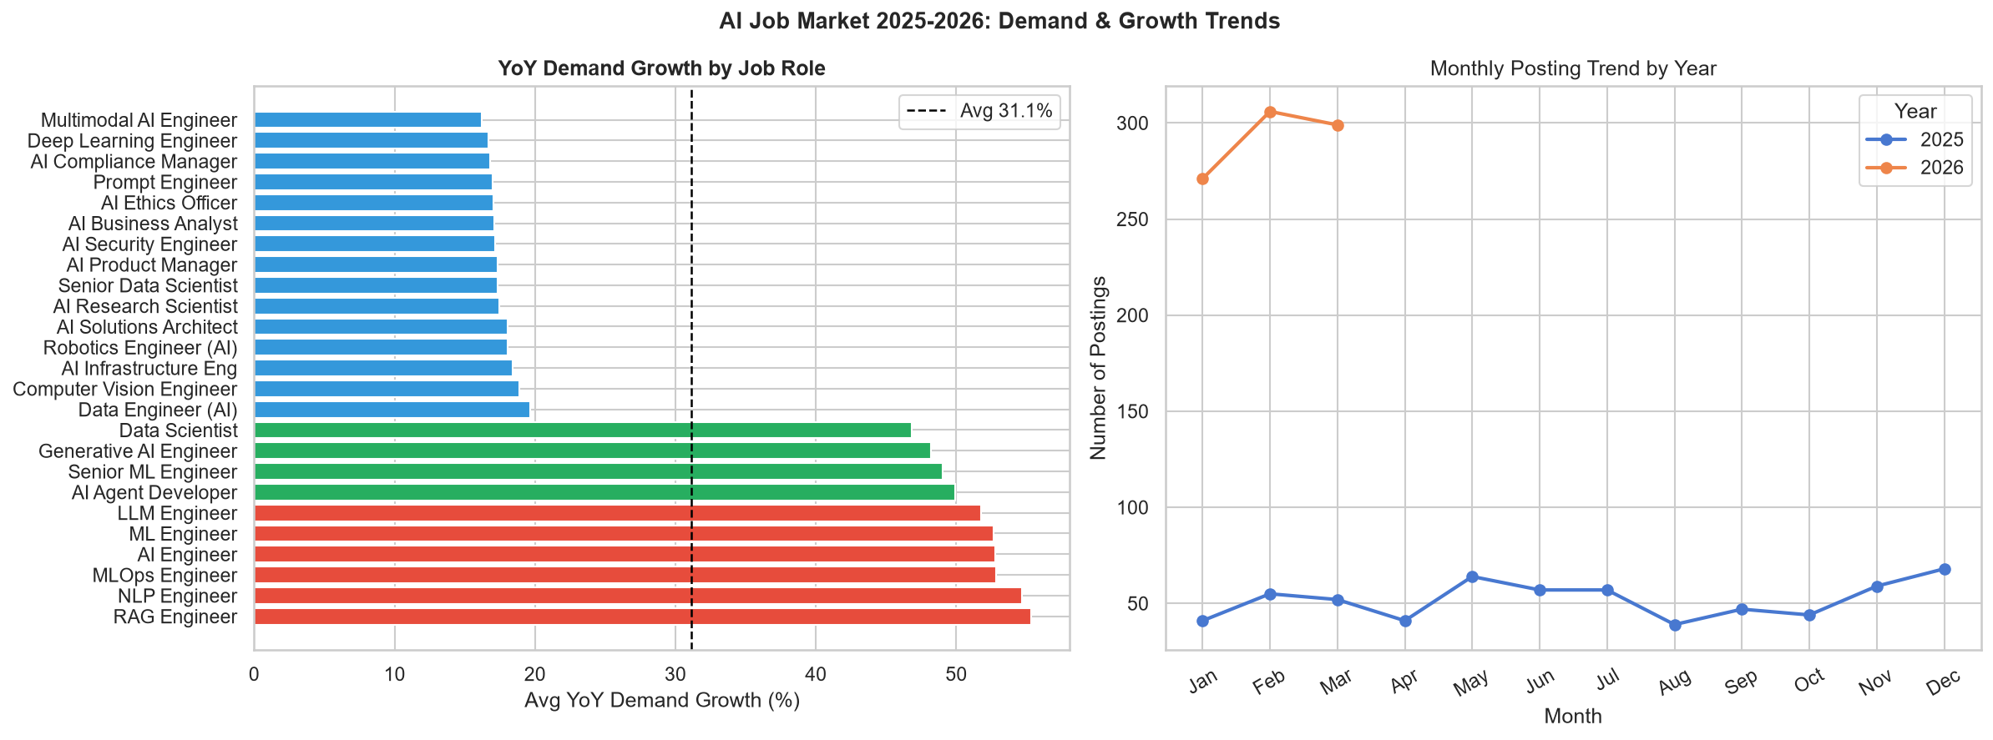
Figure 9: YoY Demand Growth by Role and Monthly Trend

8.10 Salary Heatmap
The salary heatmap reveals consistent progression across all job categories, with Lead-level positions commanding the highest salaries regardless of category. AI Engineering and Infrastructure categories show the steepest salary growth from Entry to Lead level.
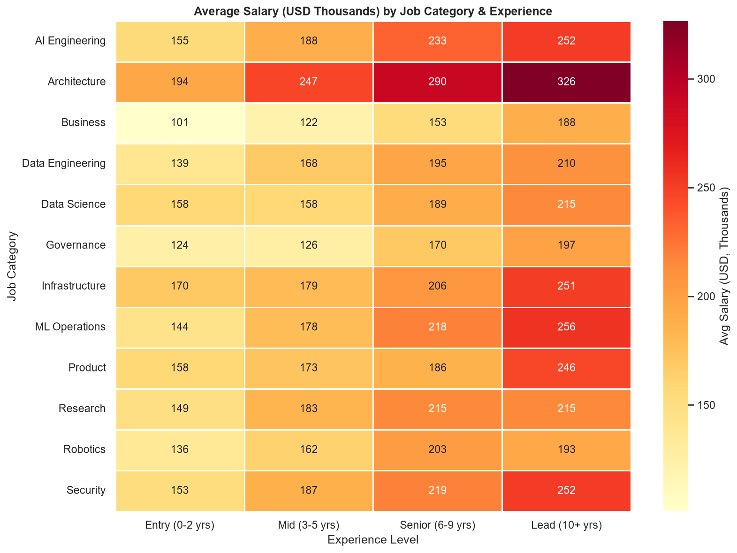
Figure 10: Salary Heatmap by Job Category and Experience Level

8.11 LLM Role Analysis
LLM-related roles (22% of postings) command an average salary of $207,746, compared to $191,309 for non-LLM roles — a premium of $16,438. This highlights the growing specialisation premium for large language model expertise.
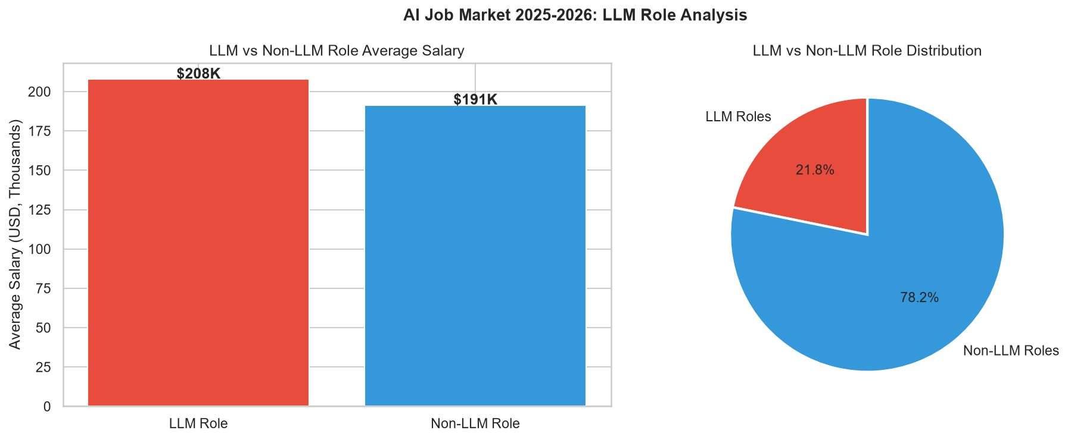
Figure 11: LLM vs Non-LLM Role Salary and Distribution

8.12 Education Analysis
Interestingly, the relationship between education level and salary is not strictly hierarchical. Bootcamp/Self-taught candidates appear in high-salary roles, suggesting that practical skills and portfolio work can compensate for formal credentials in the AI market.
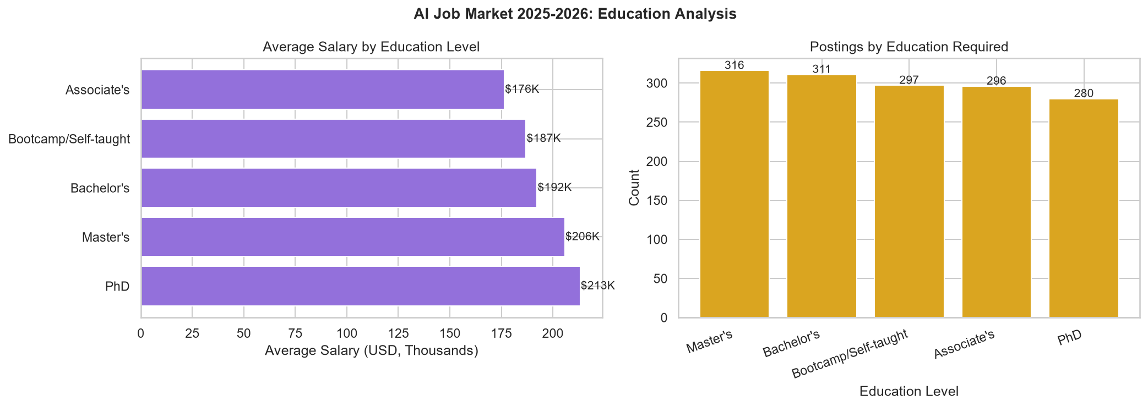
Figure 12: Average Salary and Postings by Education Level

9. KPI Analysis
The following key performance indicators were calculated from the actual dataset:
KPI | Value | Interpretation
Total Job Postings | 1,500 | Market size indicator
Unique Job Roles | 25 | Diversity of AI career paths
Countries Covered | 14 | Geographic market reach
Industries Covered | 12 | Cross-sector AI adoption
Average Annual Salary (USD) | $194,892 | Central salary benchmark
Median Annual Salary (USD) | $180,000 | Typical salary (skew-adjusted)
Max Salary Observed | $384,000 | Elite-tier ceiling
Min Salary Observed | $90,000 | Entry floor
Average Demand Score (/100) | 87.5 | Market demand intensity
Average YoY Demand Growth | 31.1% | Market growth rate
Average AI Salary Premium | 10.9% | AI vs non-AI salary uplift
Fully Remote Roles | 29.7% | Remote work availability
Hybrid Roles | 45.7% | Flexible work availability
LLM-Related Roles | 21.8% | LLM specialisation share
LLM Salary Premium | $16,438 | LLM vs non-LLM extra pay
Average Benefits Score | 7.9/10 | Compensation quality index
Highest-Paying Role | AI Solutions Architect | $251,577 avg salary
Fastest-Growing Role | RAG Engineer | 55.3% YoY growth
Top-Paying Country | USA | $226,190 avg salary
Top-Paying Industry | Automotive | $212,306 avg salary

10. Key Visualizations Summary
The following charts were generated from real dataset calculations:
- Figure 1: Salary Distribution Histogram + Salary Tier Bar Chart
- Figure 2: Top 15 Job Roles by Postings + Average Salary by All 25 Roles
- Figure 3: Mean vs Median Salary by Experience Level + Box Plot
- Figure 4: Work Model Pie Chart + Average Salary by Work Model
- Figure 5: Average Salary by Country + Postings by Country
- Figure 6: Average Salary by Industry + Postings by Industry
- Figure 7: Top 25 In-Demand AI Skills Frequency Bar Chart
- Figure 8: Postings + Salary by Company Size
- Figure 9: YoY Demand Growth by Role + Monthly Posting Trend
- Figure 10: Salary Heatmap: Job Category × Experience Level
- Figure 11: LLM vs Non-LLM Role Salary + Distribution
- Figure 12: Education Level: Salary + Posting Count

11. Key Findings
- The average AI job salary in 2025–2026 is $194,892, with a median of $180,000.
- AI Solutions Architect is the highest-paying role with an average salary of $251,577.
- Lead-level roles earn $90,016 more than Entry-level roles ($240,055 vs $150,039).
- AI roles carry an average salary premium of 10.9% over non-AI equivalents.
- LLM roles command $16,438 more than non-LLM roles on average.
- RAG Engineer is the fastest-growing role with 55.3% YoY demand growth.
- The overall average YoY demand growth is 31.1%, indicating a strong growth market.
- Average demand score across all roles is 87.5/100 — consistently high.
- 29.7% of roles are fully remote and 45.7% are hybrid, totalling 75.4% flexible work.
- USA dominates job postings (515, 34.3%) and average salary ($226,190).
- Python is the most required skill, appearing in 942 postings (62.8%).
- LLM-related roles represent 21.8% of all postings, with premium compensation.
- Average benefits score is 7.9/10 across all roles.
- Company size distribution is relatively even (290–312 postings each), with Big Tech leading on salary.

12. Risks
- Geographic Concentration: 34.3% of postings in the USA creates dependency on a single market. Economic shifts, visa policies, or regulatory changes could significantly affect AI talent flows.
- High Entry-Level Costs: Entry-level AI roles average ~$150,000 — substantially above the general market average. This makes AI talent acquisition expensive even at junior levels.
- Rapid Skill Obsolescence: The AI field evolves rapidly. Skills like Python, cloud platforms, and LLM frameworks change quickly, creating a continuous upskilling burden for professionals.
- Governance Lag: AI Compliance and Ethics roles show the lowest average demand scores (69.8–72.0/100), suggesting that governance infrastructure may be lagging behind rapid AI deployment.
- Dataset Limitation Risk: This analysis is based on 1,500 postings. Market conclusions must be verified against larger, live job market datasets before informing critical business decisions.
- Salary Inflation Risk: AI salaries are high and growing. Unsustainable growth could lead to talent market corrections, particularly in smaller companies and startups.

13. Opportunities
- RAG Engineering and LLM Engineering — fastest-growing specialisations with >50% YoY demand growth. Strong entry point for professionals transitioning into AI.
- LLM Specialisation Premium — LLM roles earn $16,438 more than non-LLM roles, providing clear financial incentive for specialisation.
- Remote Work Availability — 29.7% fully remote + 45.7% hybrid = 75.4% flexible roles. Global candidates can access premium USA/Global salaries from lower-cost locations.
- AI Salary Premium — 10.9% average premium confirms that AI skills pay significantly more, justifying investment in AI education and certifications.
- Emerging Markets — Germany, Netherlands, India, and Singapore are growing rapidly and offer high-quality AI roles outside the traditional USA/UK concentration.
- Multiple Entry Paths — Education analysis shows Bootcamp/Self-taught candidates access high-salary roles, opening AI careers to non-traditional candidates.
- Governance & Compliance — The below-average demand for governance roles represents an opportunity: as regulation increases (e.g., EU AI Act), demand for compliance specialists will surge.

14. Recommended Actions

For Job Seekers and Professionals:
- Master Python + Cloud + SQL as foundational skills — required in the majority of AI postings.
- Specialise in LLM Engineering, RAG Engineering, or Generative AI to access the highest salary tiers.
- Target Lead-level experience paths (avg $240,055) vs Entry-level (avg $150,039).
- Explore fully remote roles to access global salary benchmarks from any location.
- Build practical portfolios with LLM applications — credentials matter less than demonstrated capability.
- Upskill in MLOps and infrastructure for fast-growing operational AI roles.
- Consider roles in Germany, Netherlands, or Singapore for competitive salaries with less competition than the USA.

For Employers and Organisations:
- Invest proactively in AI governance and compliance hiring to reduce regulatory risk.
- Offer hybrid or fully remote work arrangements to attract global AI talent pools.
- Prioritise LLM and Generative AI expertise in 2025–2026 hiring roadmaps.
- Budget for premium AI talent: expect $150,039+ even at entry level.
- Build internal upskilling programmes targeting Python, cloud platforms, and LLM tools.
- Consider Bootcamp/Self-taught candidates who demonstrate strong practical AI skills.
- Benchmark salaries against the ${avg_sal:,.0f} market average to remain competitive.

15. Results & Dashboard
An interactive Streamlit dashboard was developed to allow dynamic exploration of the AI job market dataset. The dashboard features 8 analysis tabs covering all major dimensions of the dataset, with real-time filtering by year, country, experience level, work model, industry, company size, and salary range.
Dashboard Features:
- 10 KPI cards on the main page (total postings, avg salary, median salary, demand score, growth, remote %, LLM %, benefits)
- Interactive sidebar filters (year, country, work model, experience, industry, company size, salary range)
- Job Role Analysis: posting counts and salary comparison charts
- Salary Analysis: distribution histogram, salary tier, box plots, company size, LLM premium
- Skills Analysis: top-N skill frequency with dynamic category filter
- Country & Industry Analysis: choropleth-ready bar charts, postings heatmap
- Experience Analysis: mean/median bars, box plots, demand scores, education breakdown
- Work Model Analysis: pie charts, stacked bars by category and country, remote-friendly ranking
- Trends: YoY growth ranking, monthly trend lines, salary heatmap
- Insights & Actions: formatted findings, risks, opportunities, and recommended actions panels

Dashboard Screenshots:
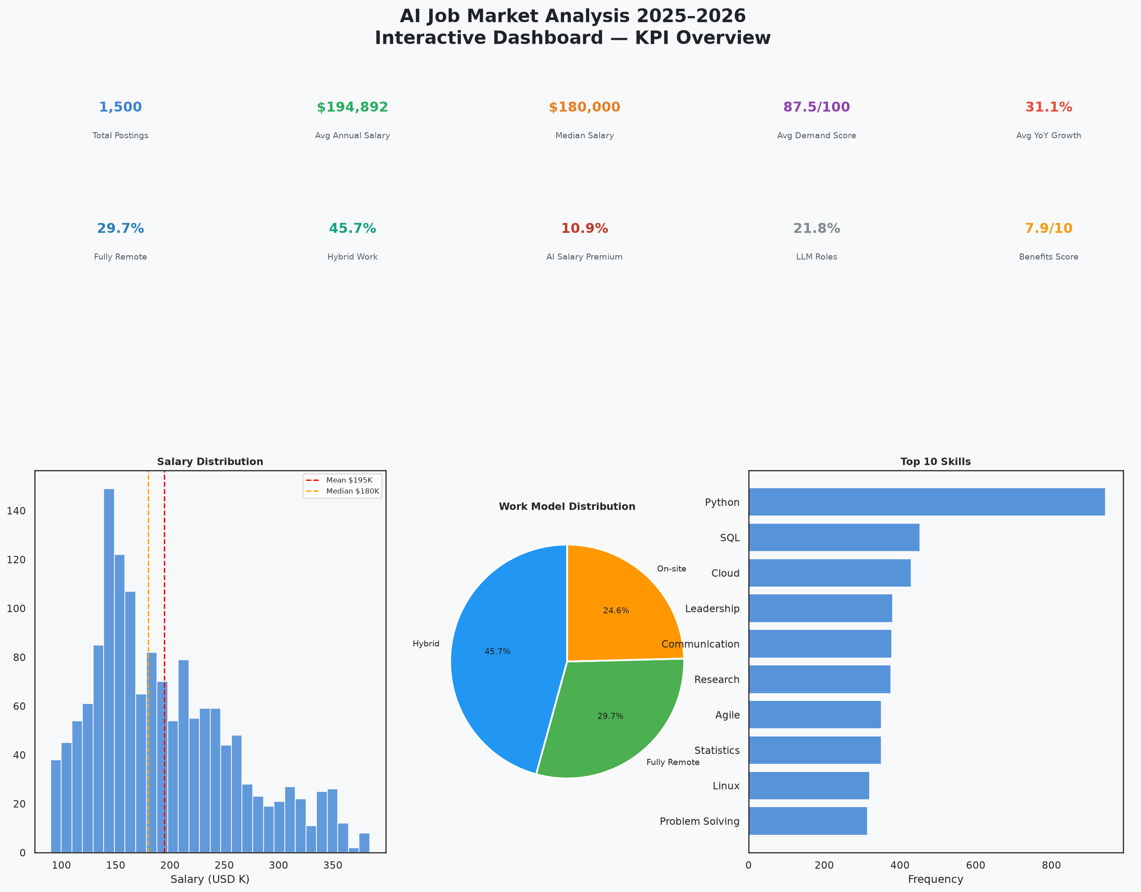
Dashboard Screenshot 1: KPI Overview Dashboard
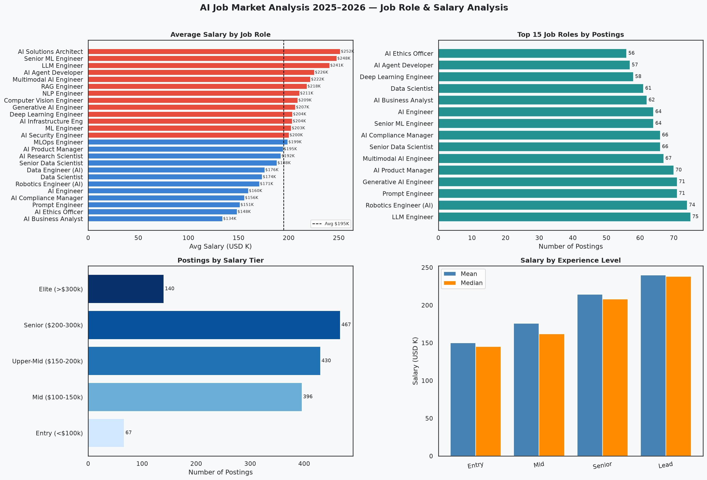
Dashboard Screenshot 2: Job Role & Salary Analysis
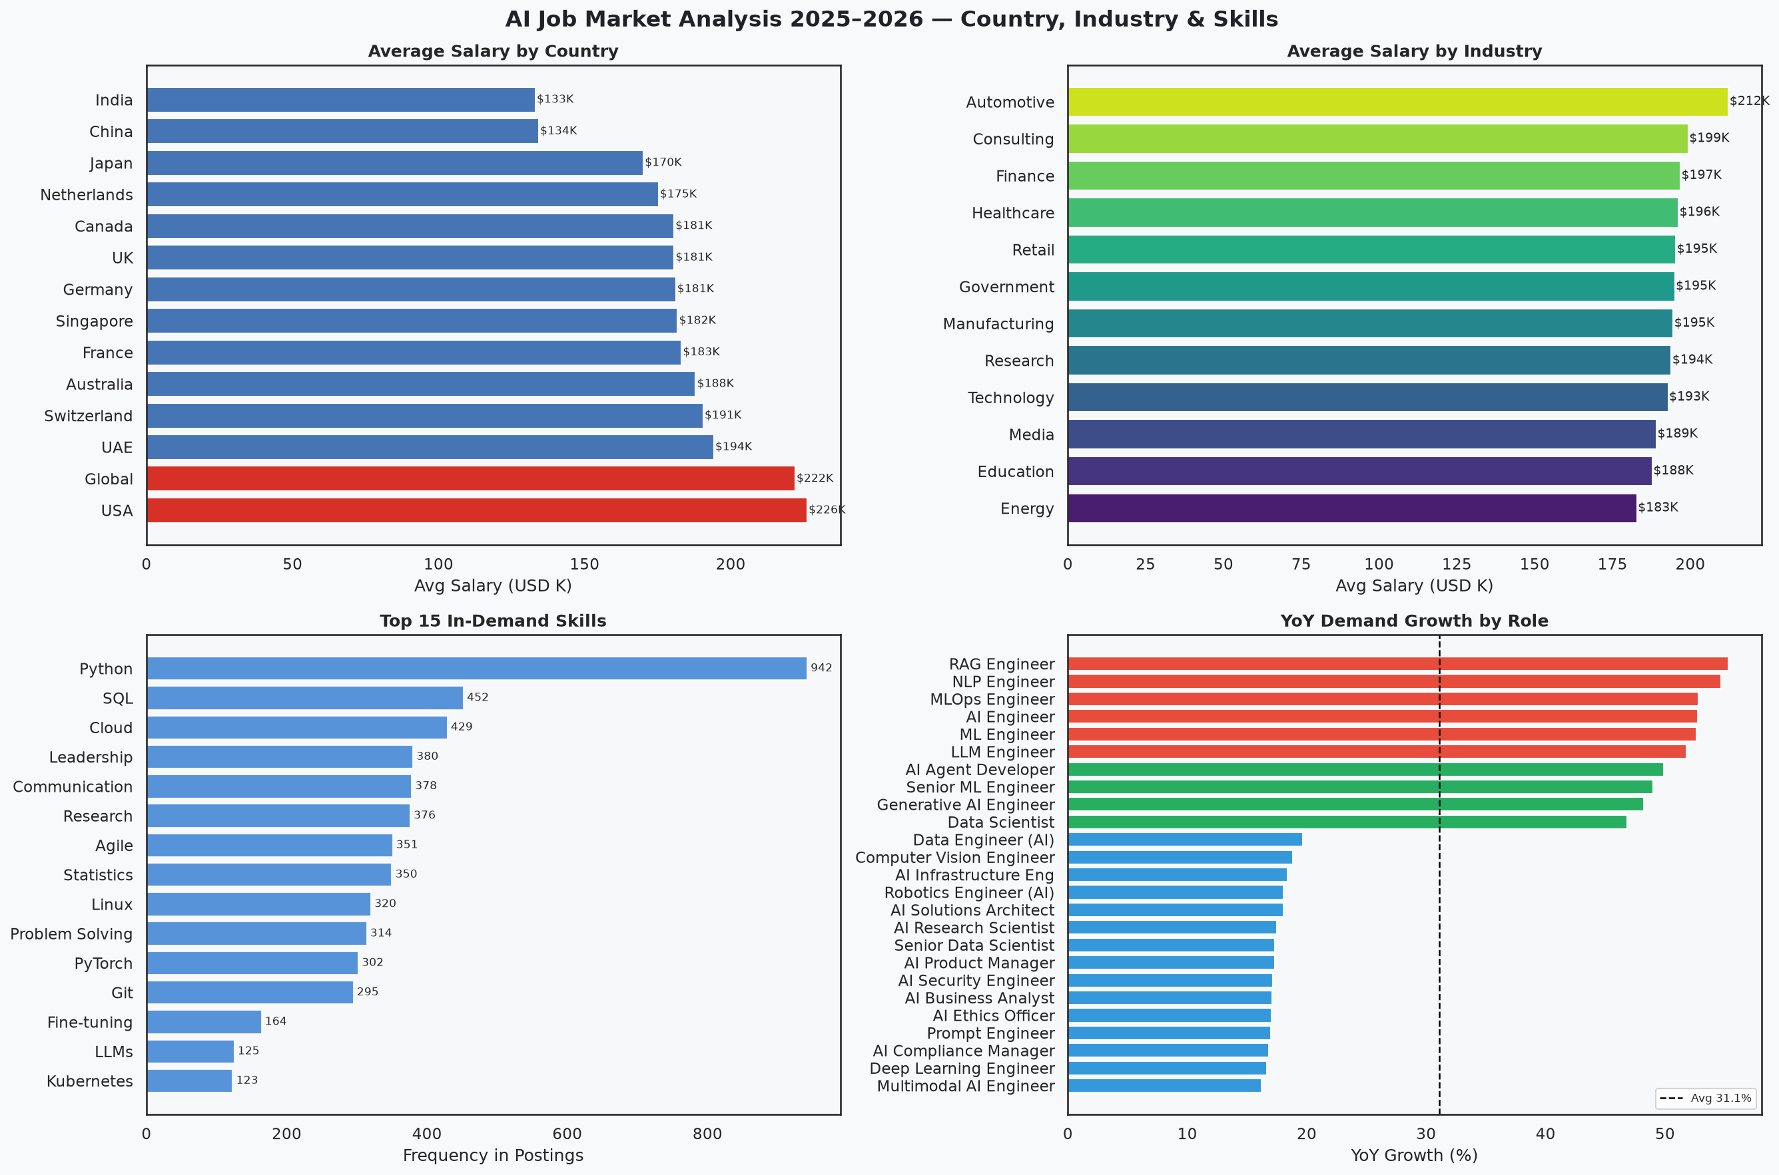
Dashboard Screenshot 3: Country, Industry & Skills
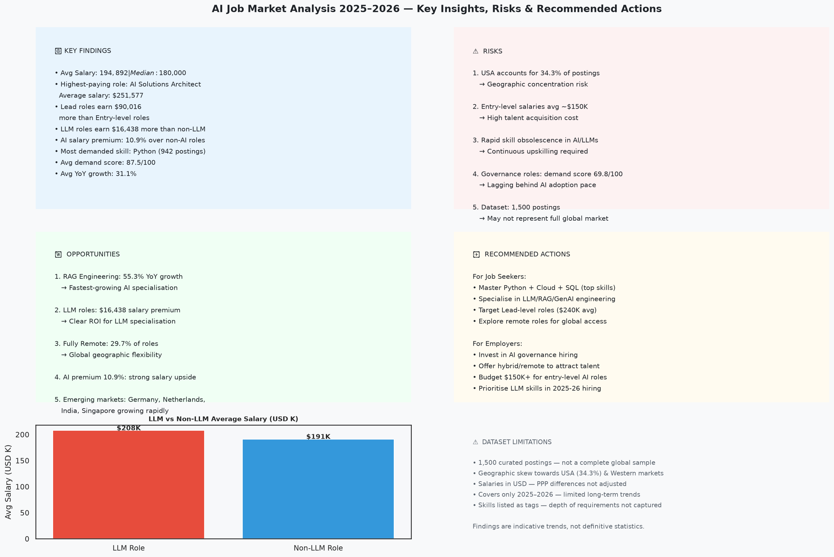
Dashboard Screenshot 4: Key Insights, Risks & Actions
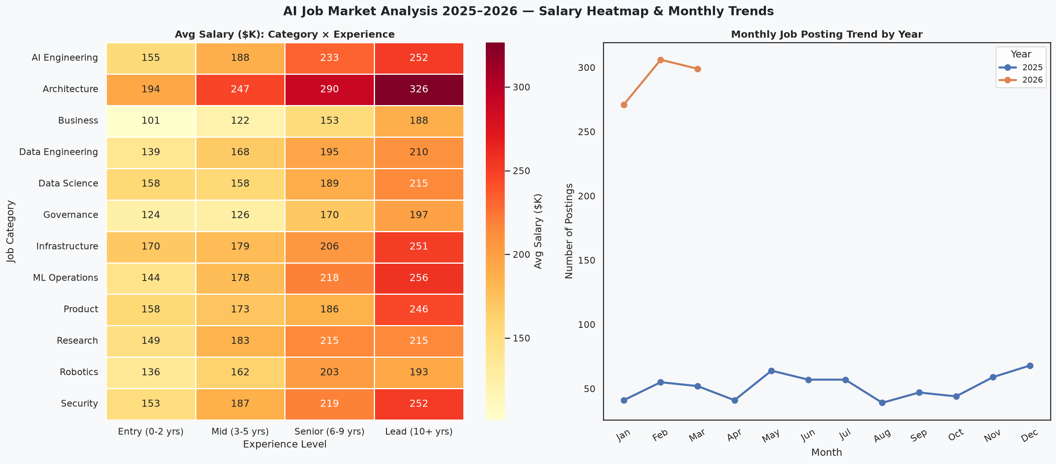
Dashboard Screenshot 5: Salary Heatmap & Monthly Trends
To run the dashboard: streamlit run app.py

16. Conclusion
This project examined 1,500 AI job postings across 14 countries, 25 unique job roles, and 12 industries for the period 2025–2026.
The AI job market demonstrates strong demand (average demand score 87.5/100), healthy growth (31.1% YoY average), and premium compensation (average $194,892 with a 10.9% AI salary premium).
LLM Engineering, RAG Engineering, and Generative AI represent the fastest-growing and highest-paying specialisations. Python remains the most universally required skill (942 postings, 62.8%). Remote and hybrid work collectively account for 75.4% of postings.
The findings provide actionable guidance for job seekers (focus on LLM/RAG skills, target Lead-level paths, explore remote roles) and employers (offer flexible work, invest in governance hiring, budget for premium AI talent).

17. Limitations
- Dataset Size: 1,500 job postings is a limited sample. Results may not represent the full global AI job market.
- Geographic Skew: USA accounts for 34.3% of postings, creating potential bias towards North American salary norms.
- Temporal Coverage: Only 2025–2026 data is covered. Longer-term historical data would enable more robust trend analysis.
- Salary Currency: All salaries are in USD. Purchasing power parity (PPP) adjustments were not applied, which may affect cross-country comparisons.
- Skill Granularity: Skills are recorded as comma/pipe-separated tags without proficiency levels, making depth of skill requirements unclear.
- Synthetic Nature: This dataset appears to be synthetically generated or curated for educational purposes. Real-world distributions may differ.
- Snapshot Analysis: A static CSV snapshot does not capture real-time market dynamics, job fill rates, or application volumes.

AI Job Market Analysis 2025–2026 | IBM Data Analytics & AI Internship Project
Dataset: Kaggle AI Job Market Dataset 2025-2026 | Analysis performed with Python

